Violence Risk Factors Map

Predicting youth and gang violence in San Jose

Parks, Recreation, and Neighborhood Services

Albert Gehami, Data Scientist

San Jose’s juvenile violent crime has risen each year since 2015. Not only is the City concerned with the rising crime rate, but it is also concerned with failing its youth. The Mayor’s Gang Prevention Task Force under the department of Parks, Recreation, and Neighborhood Services has been tasked with reducing youth delinquency through supportive services. Ideally, the Task Force can reach the youth and their communities before any crime is committed.

Figure : Juvenile Crime in San Jose over time. Data provided by San Jose Police Department Crime Investigations Unit

Identifying the communities at the highest risk of youth violence is hard. Over 200 neighborhoods inhabit San Jose, each with a reason to demand services. To provide a holistic, objective study of the City, the Mayor’s Gang Prevention Task Force hired a Data Science fellow to identify the neighborhoods with the highest risk for youth and gang violence, and ultimately to predict where youth and gang violence is likely to happen in the future.

The final product is the “Violence Risk Factor Map”, an interactive map for identifying each neighborhood’s risk for youth and gang violence (Figure 2). Each neighborhood holds an overall risk score for youth and gang violence, but also factor-specific risk scores. Factor-specific scores identify which neighborhoods need help with specific issues, like substance abuse or gang crime. Using machine learning, the overall risk scores for each neighborhood are predicted out to 2021, to help plan PRNS’s future allocation of services. This work has created a score card for past, present, and future neighborhood youth violence risk factors.

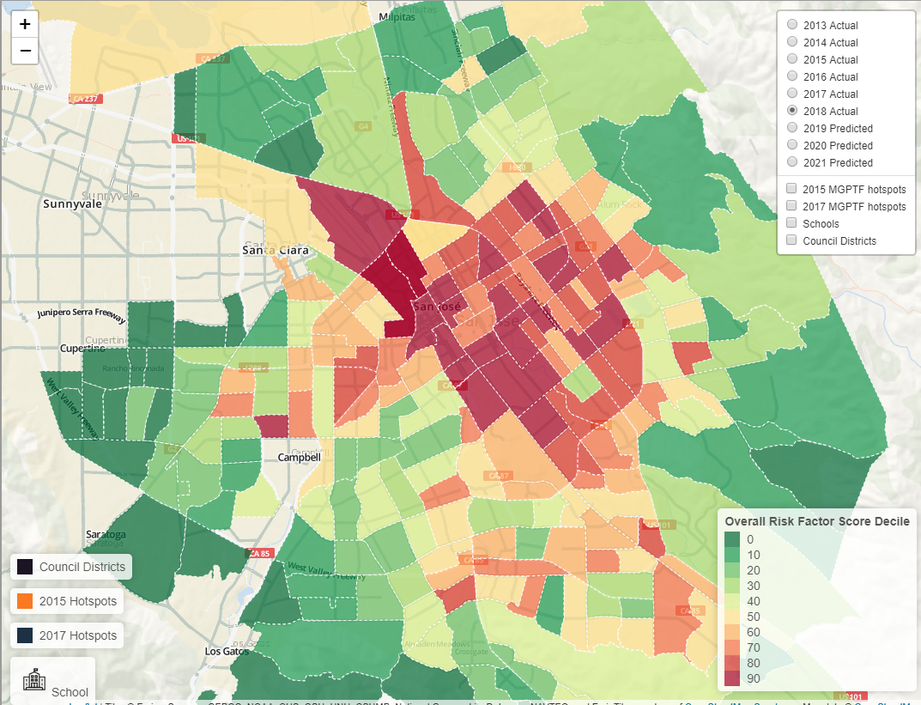

Figure : Map of Youth and Gang Violence Risk Factors for each Census Tract (loosely each neighborhood)

Our models predict the overall risk for youth and gang violence each year for 2019, 2020, and 2021 with a believed 99% accuracy. For example, here is the risk factor map for 2018 (Figure 3) compared to the *predicted* risk factor map for 2018 based on 2017 data (Figure 4).

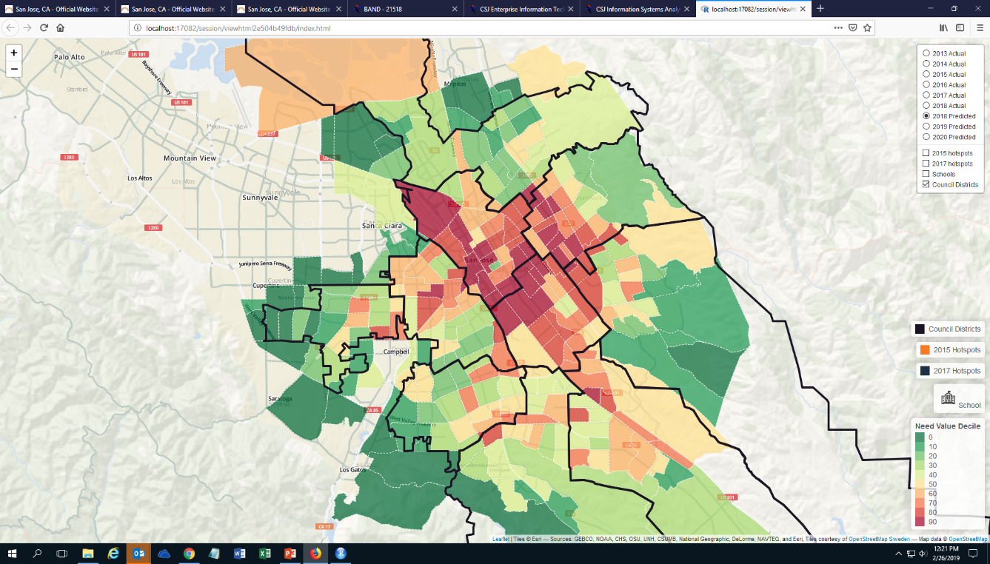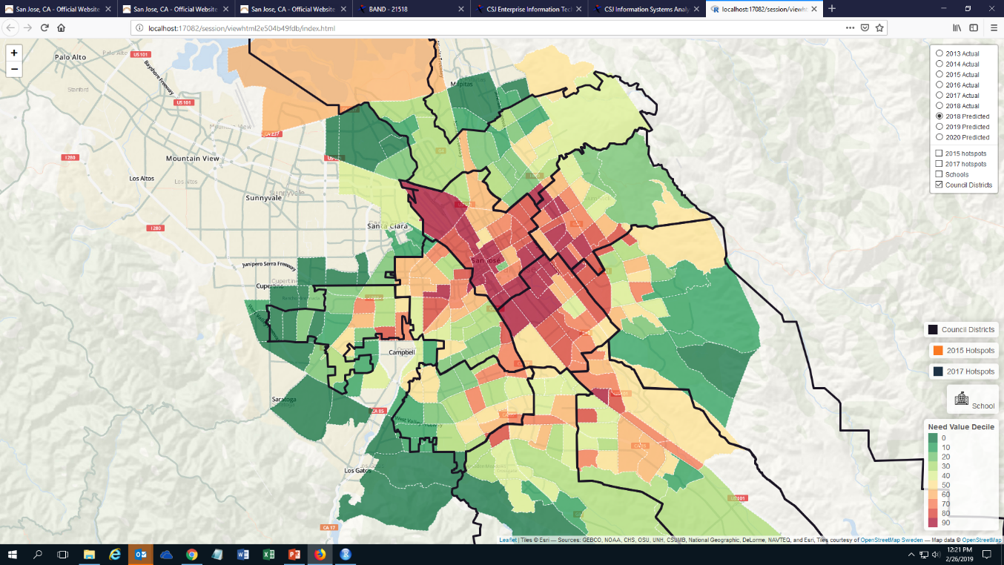

Figure 3: Actual 2018 Risk Factor Map (Left). Council Districts mapped in black for reference.

Figure 4: Predicted 2018 Risk Factor Map Using 2017 Data (Right). Council Districts mapped in black for reference.

The two maps are nearly identical, implying that the predictive models can predict into the future accurately. Through data, the task force can identify the communities with the highest risk for youth and gang violence to change the narrative of trauma and crime to support and success.

The Violence Risk Factors Map (aka “Risk Factors Map”) is an interactive tool which can be found here: <http://gehami.com/violence-risk-factors-map/>. On the map any neighborhood can be clicked to see its overall Risk Factor Score, along with the factor-specific risk scores (Figure 5). To alter the map and explore only a single, or small set of risk factors, that can be done on the toggle map here: <https://albertgehami.shinyapps.io/Violence-Risk-Factors-Map/> (Figure 7). The map can also include an overlay of schools, city council districts, and the Mayor’s Gang Prevention Task Force “Hot Spots” by selecting any of the items on the top right (Figure 6). Furthermore, the displayed year can be changed to explore past, present, and future neighborhood risk factors for youth and gang violence.

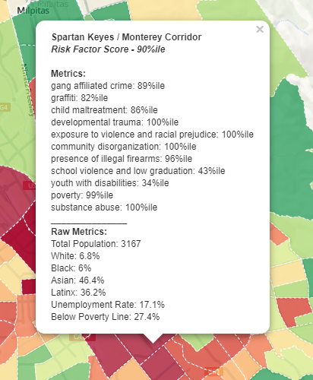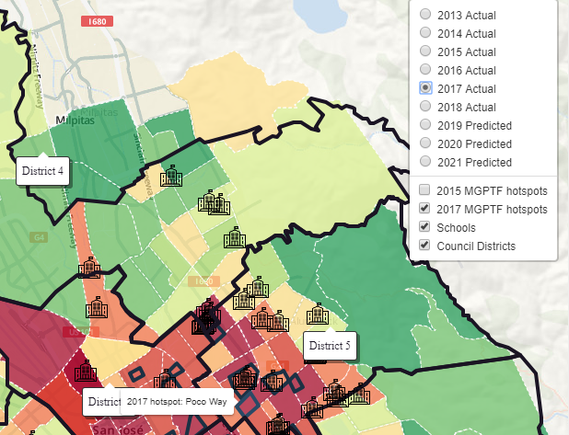

Figure 5: A detailed listing of a neighborhood's overall Risk Factor Score, along with the scores of each of the risk factor metrics.

Figure 6: Showing the possible overlays on the map. Here the council district outlines are shown, along with locations of schools and Mayor's Gang Prevention Task Force hot spots.

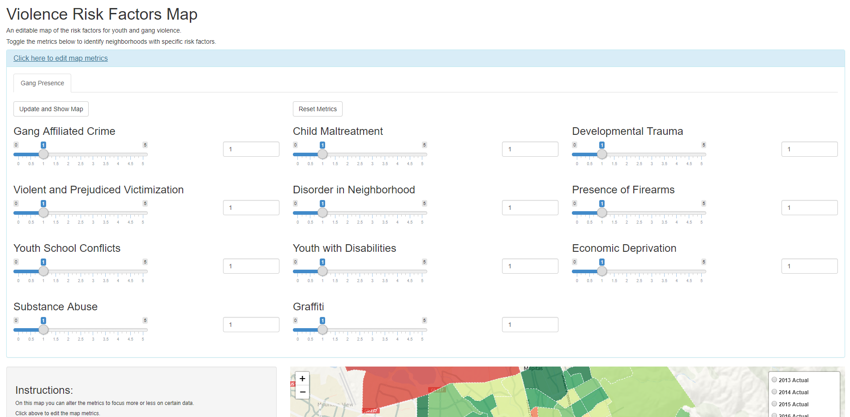

Figure 7: These toggles can be altered to re-weight the risk factors. By setting all but one factor to zero, the map will show only risk associated with that factor.

The Violence Risk Factors Map is a prototype for the City, its service providers, and the public to understand the risk factors for youth and gang violence within each neighborhood. The next step in this work is to identify what assets are available in each neighborhood, and how San Jose can leverage those assets to provide targeted support to each neighborhood. For example, if this map can identify the areas that are most troubled by substance abuse, then the City can reallocate its substance abuse prevention programs accordingly.

The Violence Risk Factors Map is best used in combination with voices from the community. Data can only tell so much of the complex story of a community’s quality of life. The data allows us to start a conversation by asking why things are the way they are. In pairing data with the voices of the community, we can improve our services to reduce youth and gang violence, and increase our City’s quality of life.